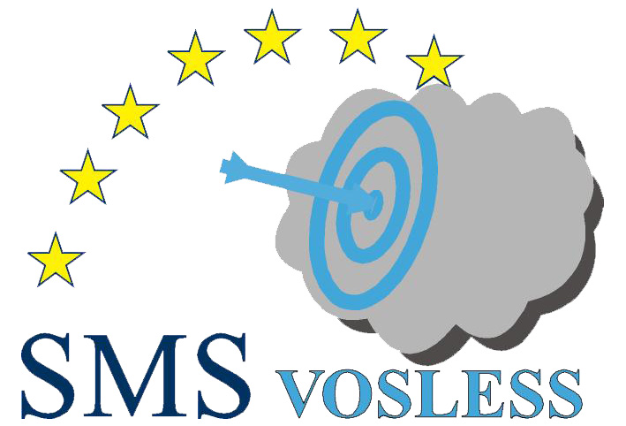 |   INTERREG IIIB CADSES

SMS-VOSLESS (Solvent Management System – Reduction of the solvent emissions in some industrial sectors)
Nova Gorica (Slovenia), 12-13 October 2006

REGISTRATION FORM

Please complete in capitals and return before 22nd of Septemer 2006 by mail
to marko.petric@bf.uni-lj.si or fax +386 1 257 22 85.

Delegate Information
Name |  |  |  |  |  | Title  (Mr, Mrs, Dr, etc)
Organisation
Address
City
State |  |  |  | Zip/Post Code
Country
Phone |  |  |  | Fax
E-mail
Active participation | □ Yes (□ Oral presentation □ Poster) □ No (tick one)
For speakers only
Needed equipment (tick one) |  | □ Standard equipment (PC with projector)
 |  | □ Other (please fill):
OPTIONAL TRANSPORT FROM TRIESTE AIRPORT (RONCHI), ITALY TO NOVA GORICA,
SLOVENIA AND BACK
(10 € one way - special reduced price payable at the Registration desk)
Needed? | □ Yes □ No (tick one)
Date and time of arrival |  |  |  |  | Flight number
Date and time of departure |  |  |  |  | Flight number

